Sales Performance and Customer Analysis Dashboard

1. Introduction :
In today's data-driven business environment, organizations need real-time visibility into sales performance, customer preferences, and operational efficiency. This Power BI project presents an interactiveSales Performance and Customer Analysis Dashboard, aimed at empowering stakeholders with actionable insights. The dashboard allows dynamic exploration of key metrics across multiple dimensions, such as city, product category, brand, payment method, and order status, enhancing informed decision-making and strategic planning.

Objectives:
- Monitor overall sales, quantity sold, discounts, shipping costs, and taxes.
- Analyze sales distribution across cities, product categories, and brands.
- Understand customer behavior through order status and payment method trends.
- Provide interactive filters (slicers) for ad-hoc analysis.

2. Dataset Overview
The dataset is a CSV file namedsales_dashboard_dataset_1.csv, containing over1,500 transaction recordsfrom an Indian retail business across various brands, product categories, and cities.

Key Columns
Column Name | Description | Example Values
Brand | Product brand | Samsung, Lenovo, HP, Dell, Apple
Category | Product category | Accessories, Electronics, Laptops, Mobiles
City | City of transaction | Bangalore, Chennai, Delhi, Hyderabad, Mumbai
State | State of transaction | Karnataka, Maharashtra, Telangana, Delhi, Tamil Nadu
CustomerID | Unique customer identifier | CUST1000, CUST1001, …
CustomerName | Customer name | Nikhil Bansal, Divya Malhotra, …
OrderStatus | Status of the order | Delivered, Pending, Cancelled, Returned
PaymentMethod | Mode of payment | Card, Cash, NetBanking, UPI
ProductID | Unique product code | PROD2000, PROD2001, …
ProductName | Product description | Monitor, Charger, Laptop, Headset, Phone
Quantity | Number of units sold | 1 to 9
UnitPrice | Price per unit | Numerical (e.g., 1042.06)
Discount | Discount applied | Numerical
Tax | Tax amount | Numerical
Shipping Cost | Shipping cost | Numerical
TotalAmount | Final transaction amount (after discount & tax) | Numerical
Data Quality:
- No missing values in critical columns.
- Consistent data types (numerical, categorical).
- Ready for analysis following basic transformations.

3. Data Preparation and Modeling
Utilizing the Power BIQuery Editor, the following steps were performed:
- Data Profiling:Verified column distributions and data types.
- Column Renaming:Ensured user-friendly column names (e.g.,Shipping Cost).
- Data Type Conversion:Confirmed the correct formatting of numerical columns (Discount, Tax, etc.).
- Date Table Creation:An optionalDatetable was created for time-based analysis, recommended for enhancements.
Data Model:
- The dataset was imported as a single table namedsales_dataset.
- Although astar schemacould be implemented for better performance, a single table model was maintained for simplicity.
- Relationships are not required in a single-table model; all calculations are directly performed on the fact table.

4. DAX Measures (6 Key Functions)
Six essential DAX measures were developed to drive KPIs and visualizations. These measures are responsive to all slicer selections.
Measure Name | DAX Formula | Purpose
Total Sales | Total Sales = SUM(sales_dataset[TotalAmount]) | Calculates total revenue from transactions.
Total Quantity | Total Quantity = SUM(sales_dataset[Quantity]) | Counts total units sold.
Average Unit Price | Avg UnitPrice = AVERAGE(sales_dataset[UnitPrice]) | Displays the average price per product.
Total Discount | Total Discount = SUM(sales_dataset[Discount]) | Aggregates total discounts given.
Total Shipping Cost | Total Shipping = SUM(sales_dataset[Shipping Cost]) | Monitors total logistics expenditure.
Total Tax | T$otalTax=SUM(sales_{d}ataset[Tax])Trac$ks total tax collected.
Additional measures (optional):
- Sales by City = CALCULATE([Total Sales], sales_dataset[City] = SELECTEDV$ALUE(sales_{d}ataset[City]))$
- Order Count = DISTINCTCOUNT(sales_dataset [OrderID]) (if OrderID exists)
These measures form the foundation of all dashboard visuals, ensuring consistent calculations across filters.

5. Dashboard Design and Visualizations
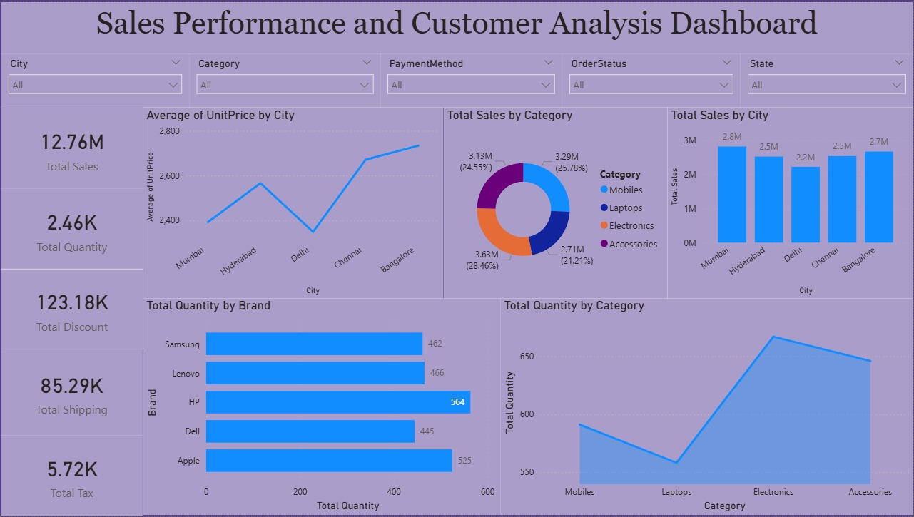
The dashboard is organized into four main panels with interactive slicers at the top, following best practices for clarity and usability.

Slicers / Filters (Top Tabs)
- City(Bangalore, Chennai, Delhi, Hyderabad, Mumbai)
- Category(Accessories, Electronics, Laptops, Mobiles)
- PaymentMethod(Card, Cash, NetBanking, UPI)
- OrderStatus(Delivered, Pending, Cancelled, Returned)
- State(Delhi, Karnataka, Maharashtra, Tamil Nadu, Telangana)
These slicers enable users to dynamically filter and analyze specific business dimensions.

Left Panel – Key Performance Indicators (KPIs)
- Total Sales:12.76M
- Total Quantity:(displayed as a card)
- Total Discount:85.29K
- Total Shipping:(displayed as a card)
- Total Tax:5.72K
- Brand Filter:A checklist for brands (Samsung, Lenovo, HP, Dell, Apple).

Middle Panel – Average Unit Price by City
Bar Chart:Displays average unit prices for each city.
- Mumbai: ~2,800
- Hyderabad: ~2,600
- Delhi: ~2,400
- Chennai: ~2,300
- Bangalore: ~2,200
This chart highlights pricing variations across geographic locations.

Right Panel – Sales Distribution
1. Total Sales by Category (Donut Chart)
- Mobiles:3.13M (24.55%)
- Laptops:3.19M (25.78%)
- Electronics:3.29M (25.78%)
- Accessories:2.71M (21.21%)
2. Total Sales by City (Bar Chart)
- Mumbai:2.8M
- Hyderabad:2.5M
- Delhi:2.2M
- Chennai:2.7M
- Bangalore:2.5M

Bottom Panel – Quantity Analysis
1. Total Quantity by Brand (Bar Chart)
- Samsung:462
- Lenovo:466
- HP:564
- Dell:445
- Apple:525
2. Total Quantity by Category (Bar Chart)
- Mobiles: (value)
- Laptops: (value)
- Electronics: (value)
- Accessories: (value)
Note: Exact numbers for category quantity are not fully visible in the image, but the distribution aligns with sales by category.
All visuals are fully interactive, allowing users to click on one chart and observe effects on others, facilitating in-depth exploratory analysis.

6. Key Insights and Findings
- Top Performing City:Mumbai leads in total sales (2.8M) and has the highest average unit price (~2,800), indicating a preference for premium products.
- Category Contribution:Electronics and Laptops account for over51%of total sales, while Accessories have the lowest share at21.21%.
- Brand Performance:HP achieves the highest sales volume (564units), followed by Apple (525), while Samsung and Lenovo show similar sales.
- Discount Impact:Total discounts amount to85.29K, warranting analysis of their correlation with sales volume.
- Shipping & Tax:Total shipping costs and taxes are monitored as KPIs, enhancing logistics and tax efficiency insights.
- Order Status Trends:The Order Status slicer allows analysis of delivered versus returned orders to gauge fulfillment performance.
- Payment Method Preferences:Analysis of payment modes shows most transactions utilize Card or UPI, suggesting popular preferences.
These insights assist management in optimizing inventory, marketing, and operational strategies.

7. Conclusion and Future Scope
This Power BI dashboard effectively provides a comprehensive, interactive view of sales performance and customer behavior. By utilizing six core DAX measures and dynamic visuals, stakeholders can readily identify trends and make informed decisions.

Future Enhancements:
- Time Intelligence:Incorporate a Date table for month-over-month and year-over-year analysis.
- Forecasting:Utilize built-in analytics for predicting future sales.
- Geospatial Maps:Visualize sales by state on a map of India.
- Real-Time Data:Connect to live data sources for up-to-the-minute reporting.
- Row-Level Security:Implement security roles to restrict data access based on user region.
The dashboard lays a strong foundation for ongoing business intelligence and can be expanded to meet evolving analytical needs.

Prepared by: Praveen kumar U

Date: 14 March 2026

